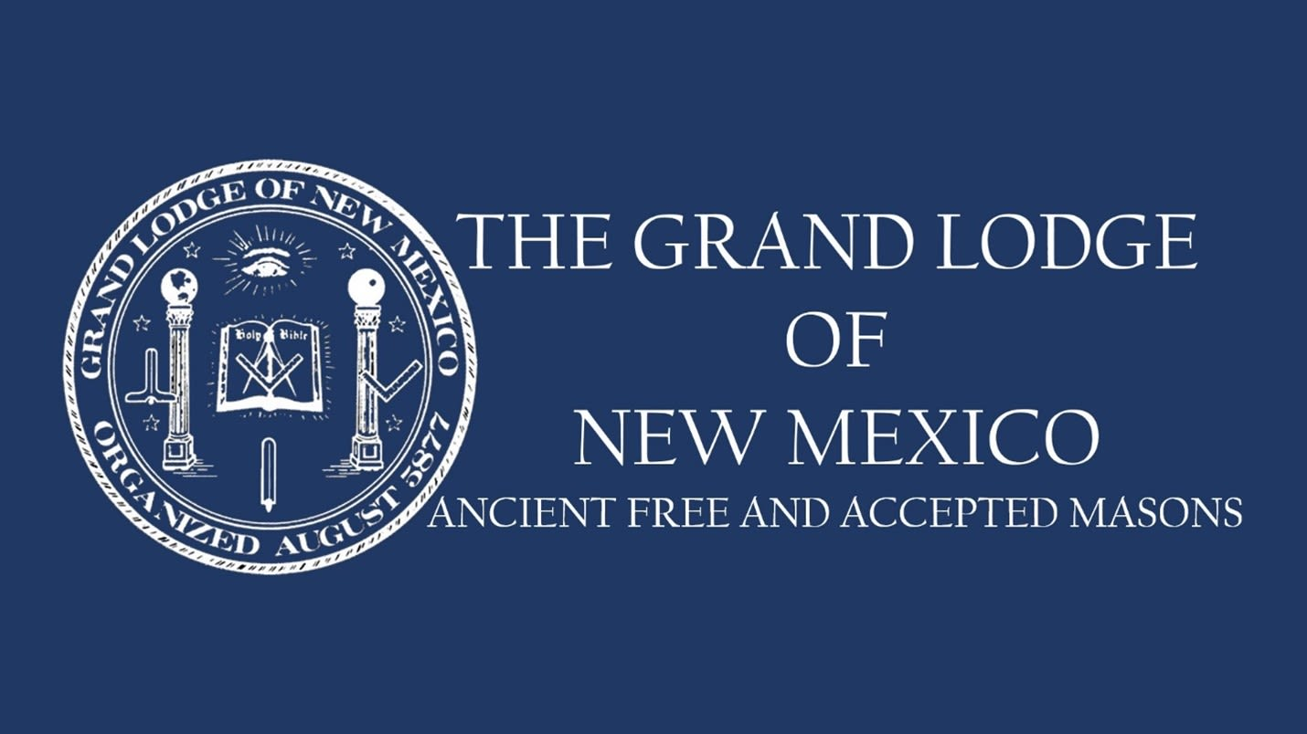

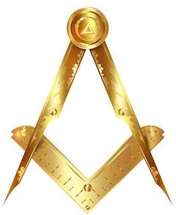
District 4 of the Grand Lodge of New Mexico invites you to a night of fun and fellowship.
Join Grand Master Robin Justice on the patio at Buffalo Wild Wings for a purely social event – no meeting, no agenda. Reconnect with members of our greater Masonic family, meet new Brothers from our area Lodges, and enjoy time together.

District 4
Masonic Mixer
Tuesday, April 29, 2025
6:00pm – 10:00pm
1700 Towne Center Ln.
Albuquerque, NM 87106

